NodeQuiz Technical Design Document

Prepared for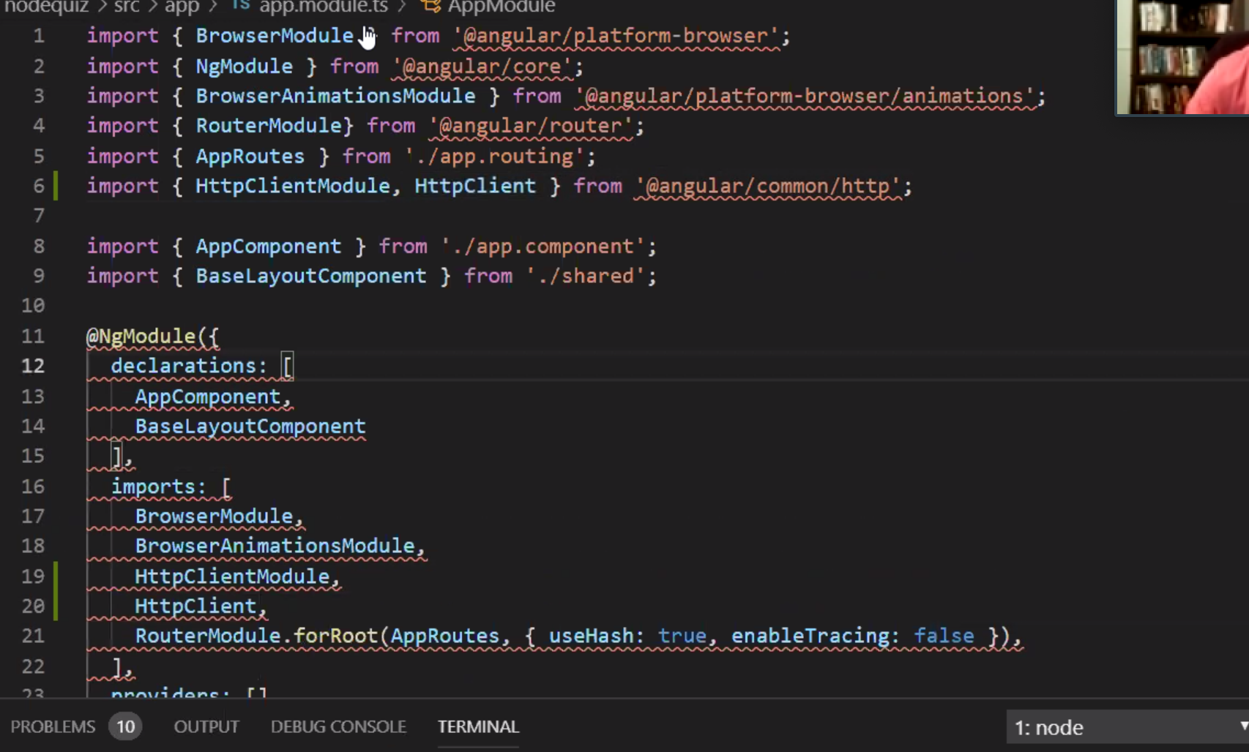: Professor Krasso

Prepared by: Alan Edwards

September 18, 2019

## Objective

The purpose of this project is to complete an application for NodeQuiz. This application will provide a quiz functionality for internal use at NodeQuiz. NodeQuiz will also provide a slideshow to accompany each quiz. The results from these quizzes will be saved and allow for score review. Sign into the application by providing ID.

## Terminology

Angular - Angular is a TypeScript-based open-source web application framework led by the Angular Team at Google and by a community of individuals and corporations.

MongoDB – MongoDB is a cross-platform document-oriented database program. Classified as a NoSQL database program, MongoDB uses JSON-like documents with schema.

NodeJS – Node.js is an open-source, cross-platform, JavaScript run-time environment that executes JavaScript code outside of a browser.

Version Control – A component of software configuration management, version control, also known as revision control or source control, is the management of changes to documents, computer programs, large web sites, and other collections of information.

## Persona’s

Personas are fictional characters that are used to represent the different types of customers who interact with your brand and site. They help us better understand customer goals, needs, feelings, influences, and frustrations. For this assignment proto-persona’s will be used as they are based on assumptions and not the product of time spent understanding real customers. We benefit from proto-personas by using them to better understand who we’re designing for and to inform our decisions of how to create their experience.

## 

## User Stories

A user story is a tool used in Agile software development to capture a description of a software feature from an end-user perspective. A user story describes the type of user, what they want and why. A user story helps to create a simplified description of a requirement.

1. As an end-user I should be able to login into the application using my employee ID
2. As an end-user I should be able to choose from three quizzes
3. As an end-user I should be able to view the results from the quiz I completed
4. As an end-user I should be able to view the cumulative results of all the quizzes I have taken
5. As an end-user I should be able to use the application with my laptop
6. As a super user I should be able to elect to take the quiz without having to go through the entire slideshow and take the quiz when I want.
7. As a super user I should be able to get to the cumulative score page from my dashboard
8. As a super user I should be able to easily interact with the application with a trackpad/mouse
9. As a super user I should be able to view the slides without taking the quiz so that I can review the material at any time.
10. As a super user I should be able to flip back and look for an answer while taking the quiz
11. As the boss I should be able to have update quizzes to the application
12. As the boss I should have the ability to review the cumulative scores of employees
13. As the boss I should have the ability to review the cumulative score of a single quiz to benchmark employees
14. As the boss I should be able to view cumulative scores from my dashboard
15. As the boss I should be able to reset user accounts.

## Estimated Costs

Below is the estimated cost based upon the proposed project plan and an hourly rate of USD $170. The represented estimated cost is a reasonable accurate estimate of the total costs to be incurred based on the information it has received to date from Client. The cost estimates fort the work described may increase or decrease due to factors outside of our control, such as failed assumptions.

| Description | Hrs | Cost |
| --- | --- | --- |
| Front-end Development  Back-end Development  Database Setup / Development  Unit Testing  UI Testing  Total | 8 | $‎ 1,360 |
| Back-end Development | 16 | $‎ 2,720 |
| Repo setup / environment set up/ hardening tasks | 8 | $‎ 1,360 |
| Unit testing | 8 | $‎ 1,360 |
| UI Testing | 4 | $‎ 680 |
| Total | **44** | **$‎ 7,480** |

## Prototypes:

Login Page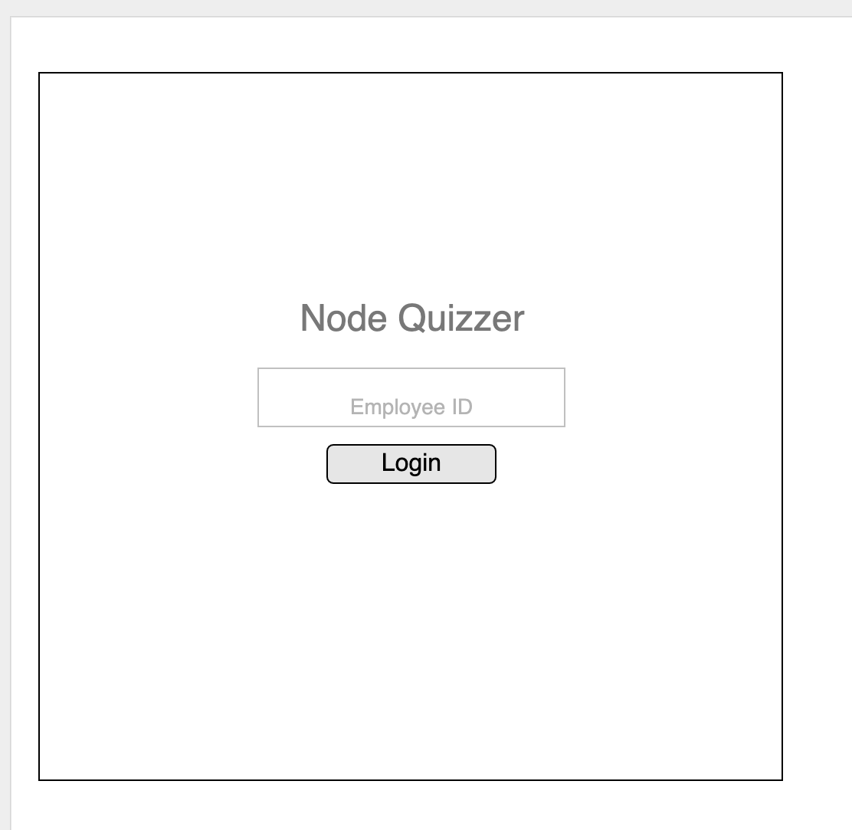

Dashboard

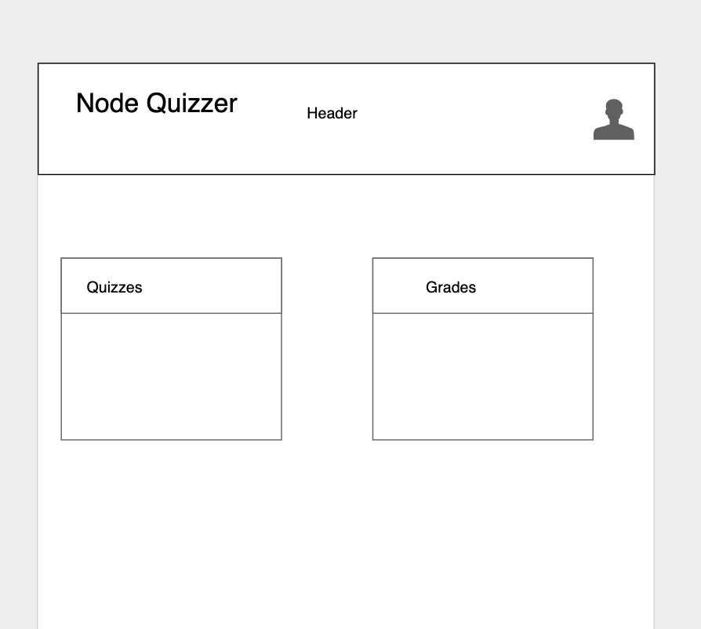

Quiz Page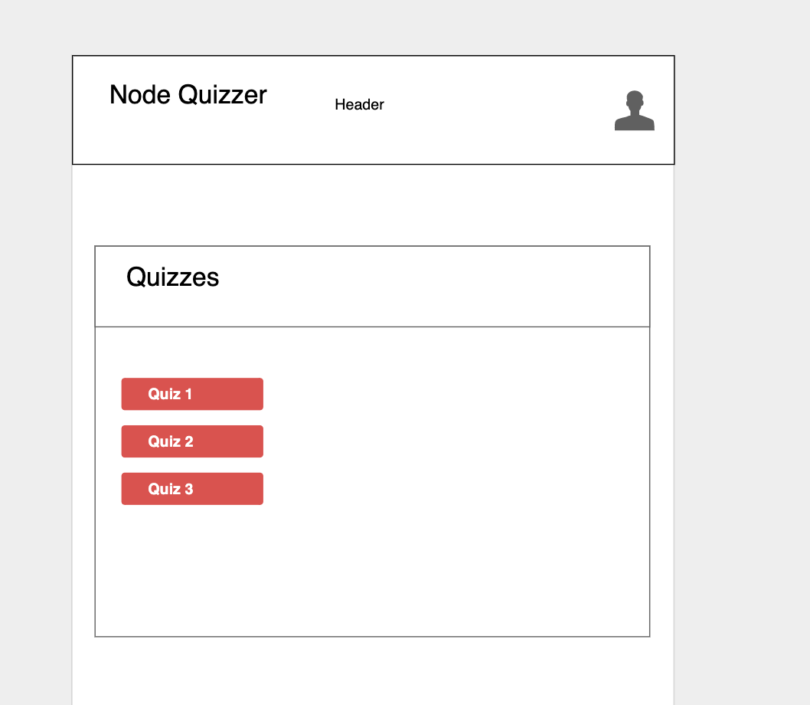

Grade Page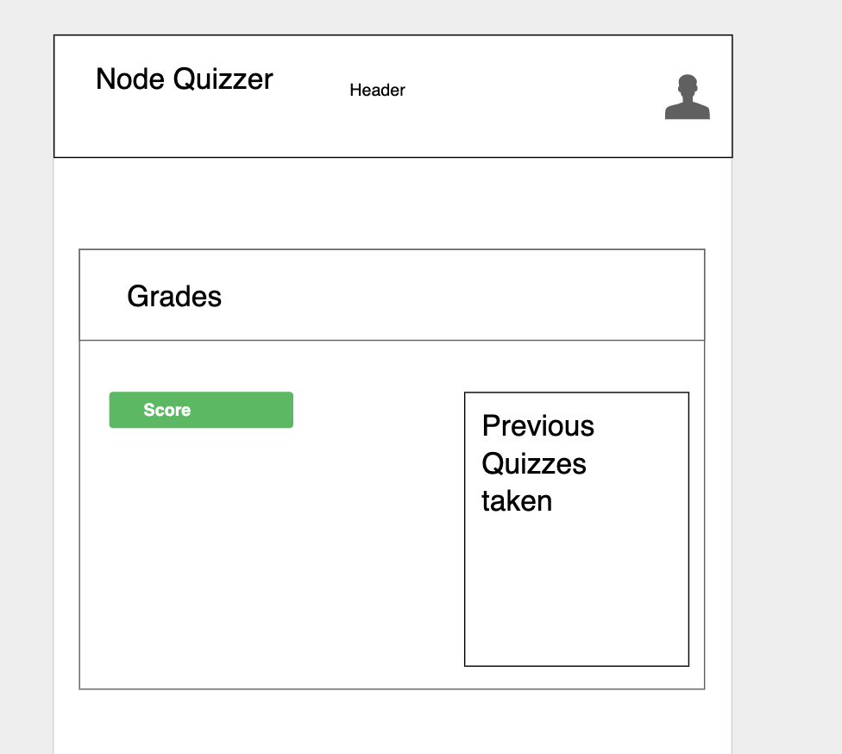

SlideShow Page`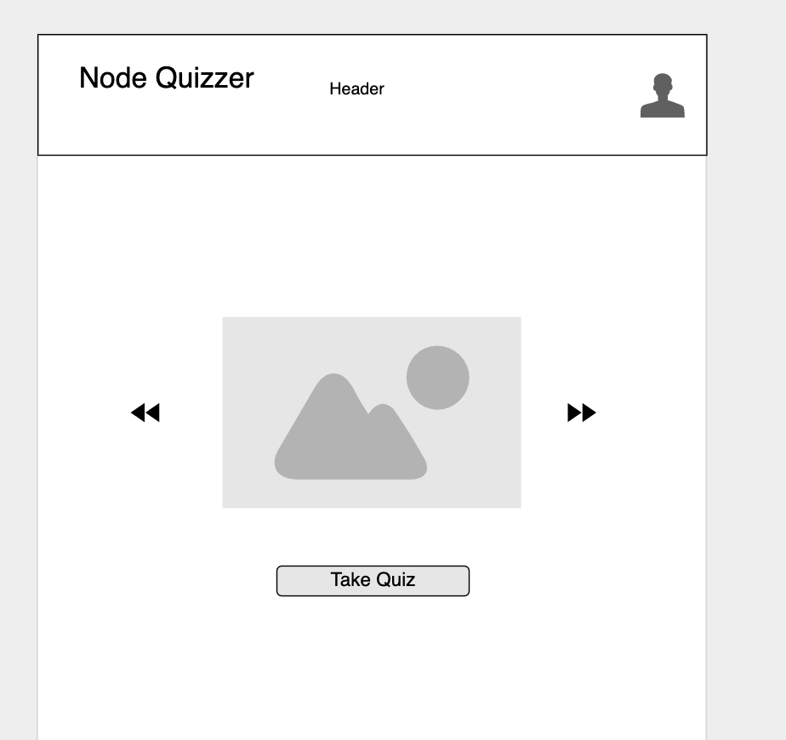

Questions Page: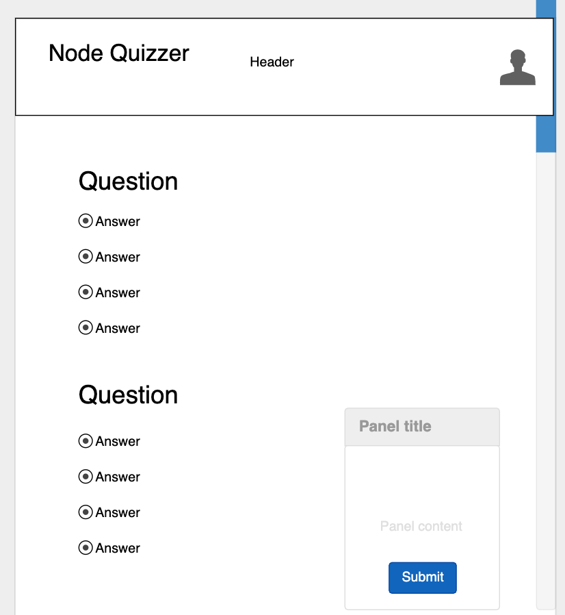

Results Page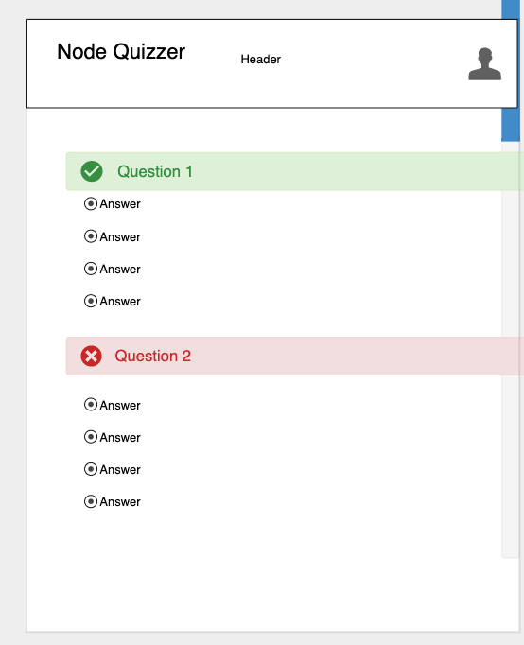

## Object Relational Diagram

## NoSQL Document Diagram

## NoSQL Data Structure (Users Collection)

## NoSQL Data Structure (Completed Quizzes Collection)

## NoSQL Data Structure (Quizzes Collection)